**National Sun Yat-sen University**

**Department of Electrical Engineering**

**112-1 Practical Digital System Design**

**HW3 Synopsys Design Vision EDA Tool**

**Name: 胡庭翊**

**Student ID: B103015006**

1. **Synthesis Process**

In this homework, we have to synthesize ripple-carry-adder, carry-look-ahead-adder, votor and medium in our homework1 and homework2.

Following is the synthesis procedure:

1. **Check Setup File**

First open XShell and cd to our target folder, check the folder in which the design compiler is to be executed contains the .synopsys_dc.setup file by typing ‘ls –a’.

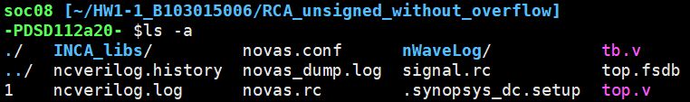

1. **Invoke Design Compiler**

Type ‘dv’ to invoke the design compiler.

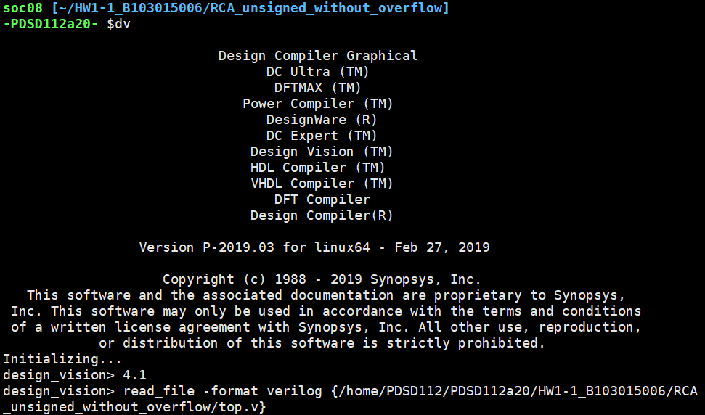

1. **Check if library is correctly loaded**

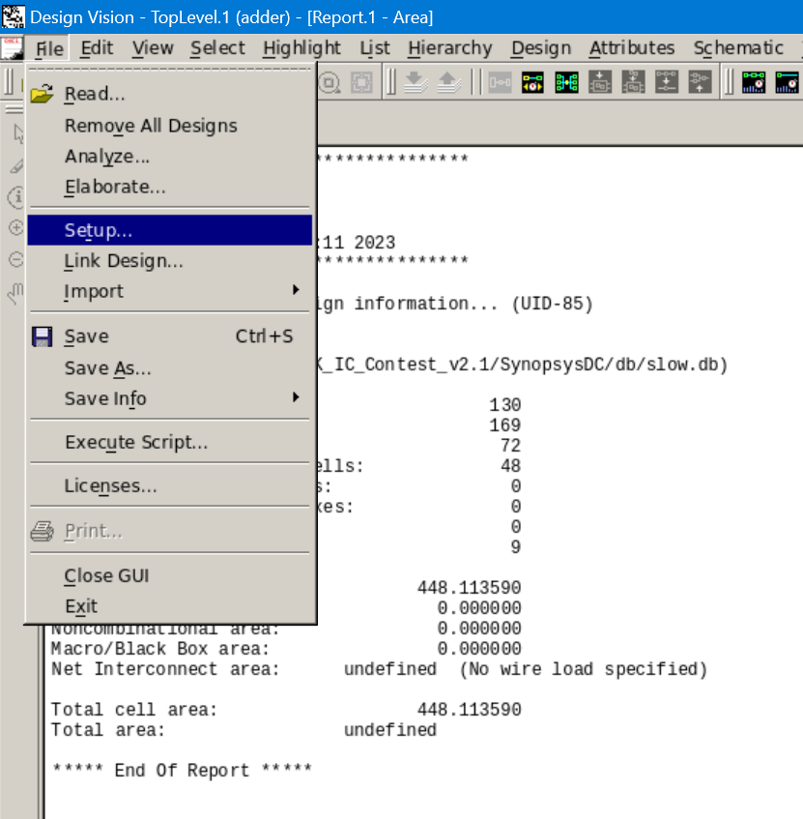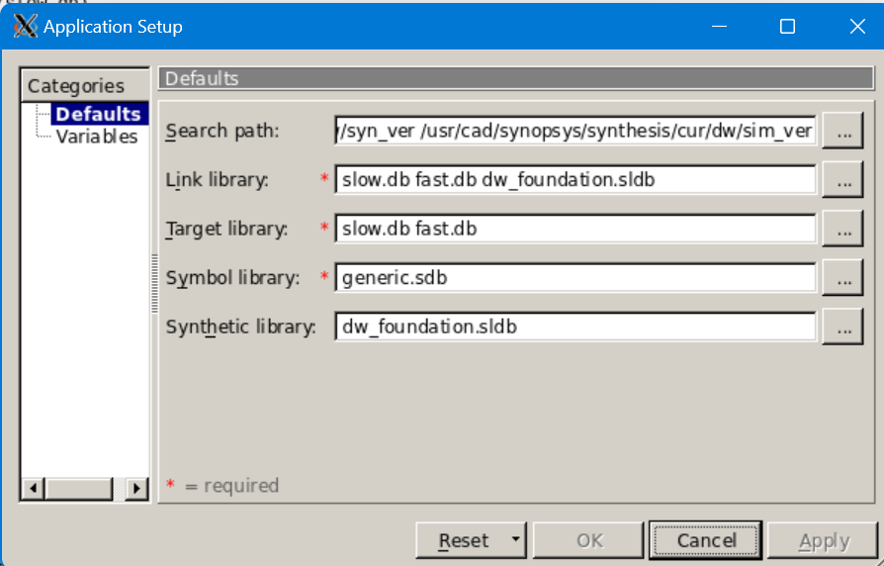

The library is correctly loaded.

1. **Read file**

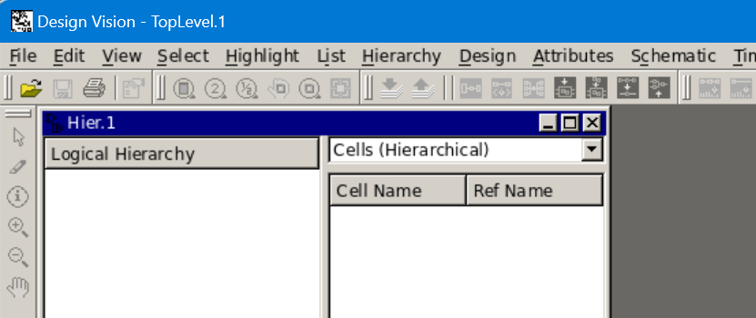

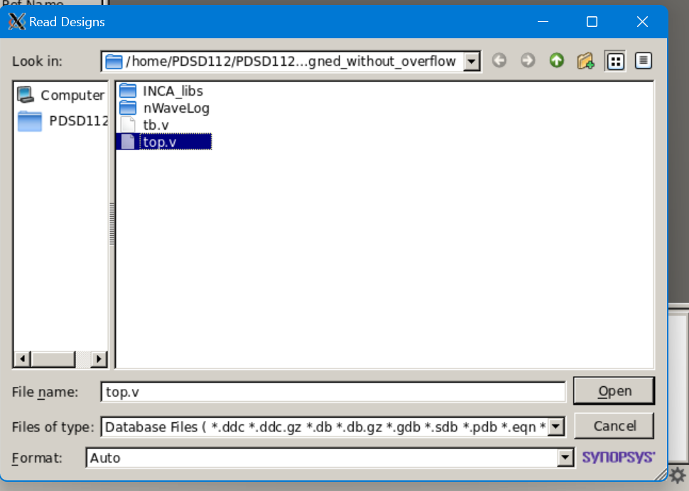

Check if any errors or warnings appear.

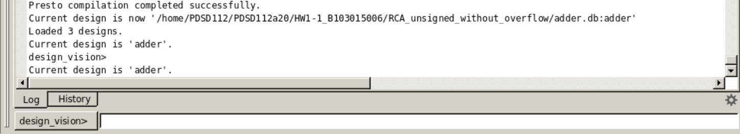

1. **Symbol View**

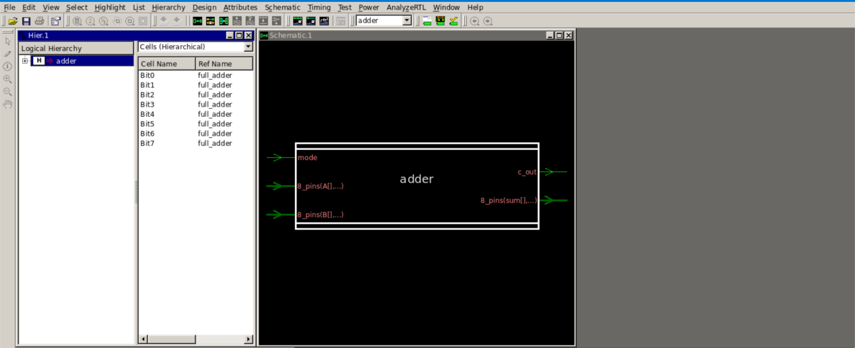

1. **Prevent Possible Assign Statement Problem**

Type ‘set_fix_multiple_port_nets -all -buffer_constants’ in the command line to prevent assign statement problem.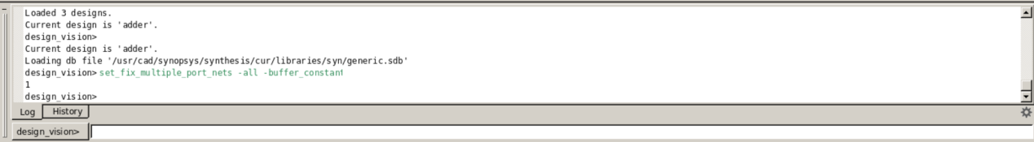

1. **Compile Design**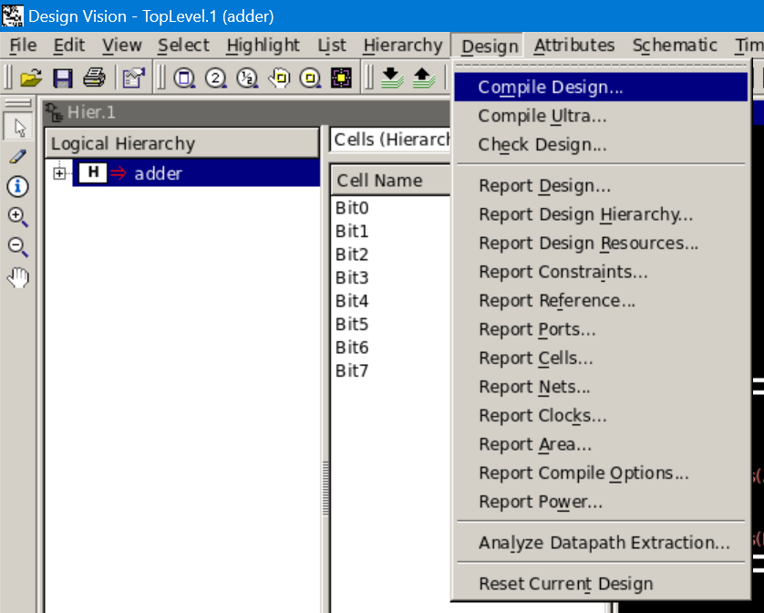

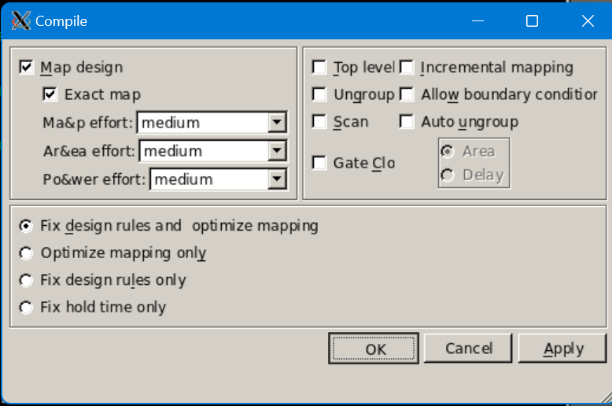

Check if any errors or warnings exist.

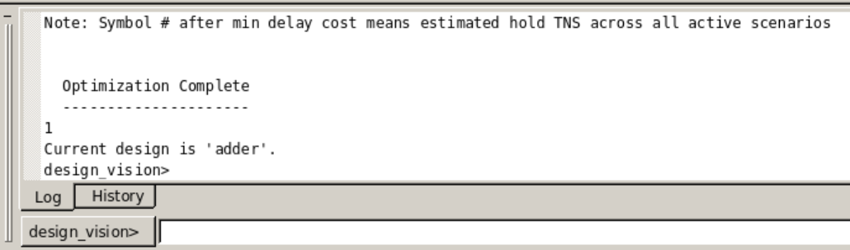

1. **Area Report**

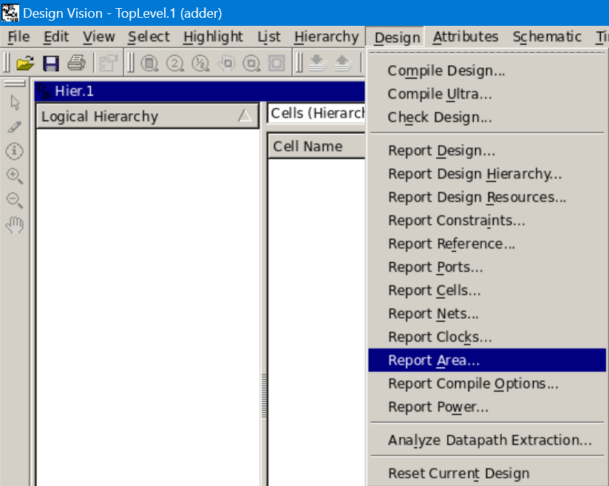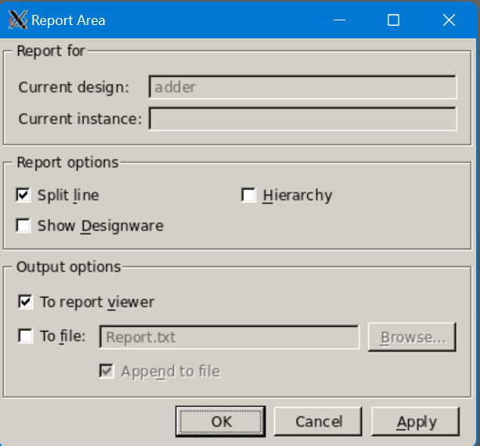

The output result of the area report will be shown as below.

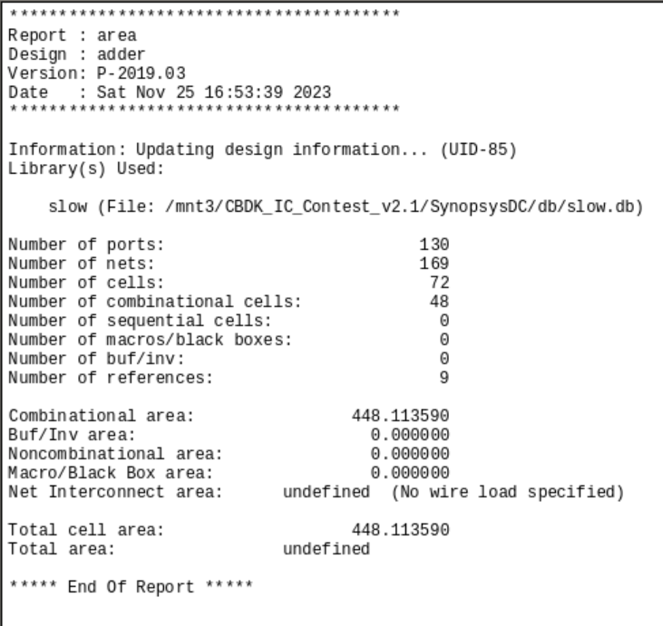

Unit: um $×$ um

Gate count = reported area/ area of a NAND2 gate

Area of a NAND2 gate is approximately:

* 5 um $×$ um for a 0.13um technology
* 10 um $×$ um for a 0.18um technology

1. **Timing Report**

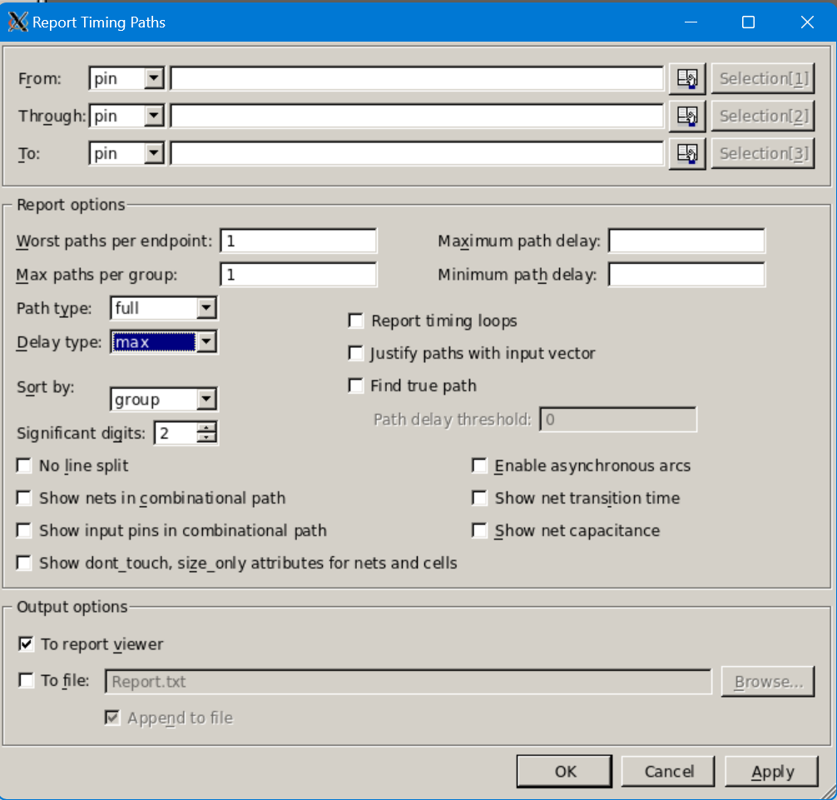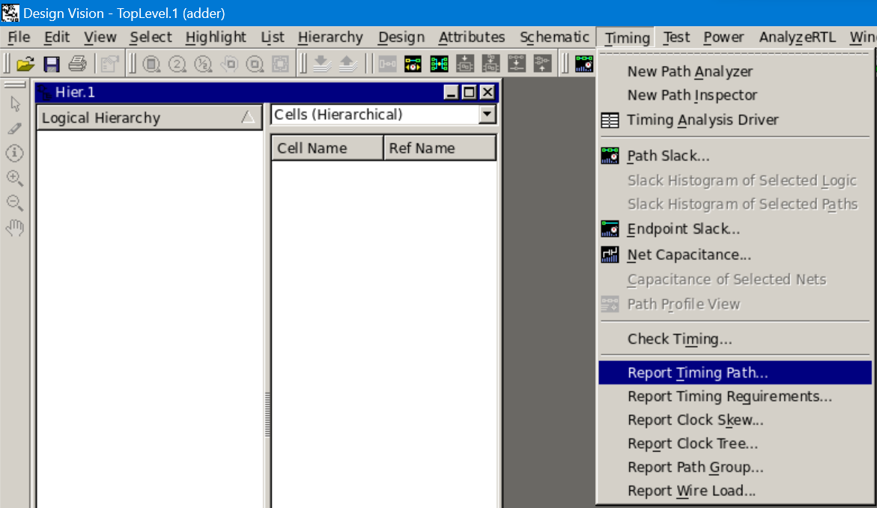

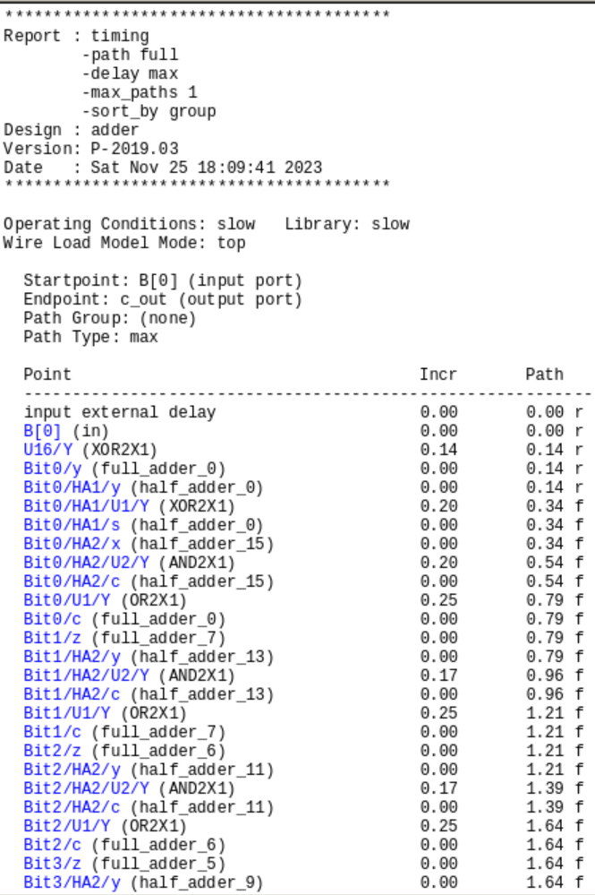 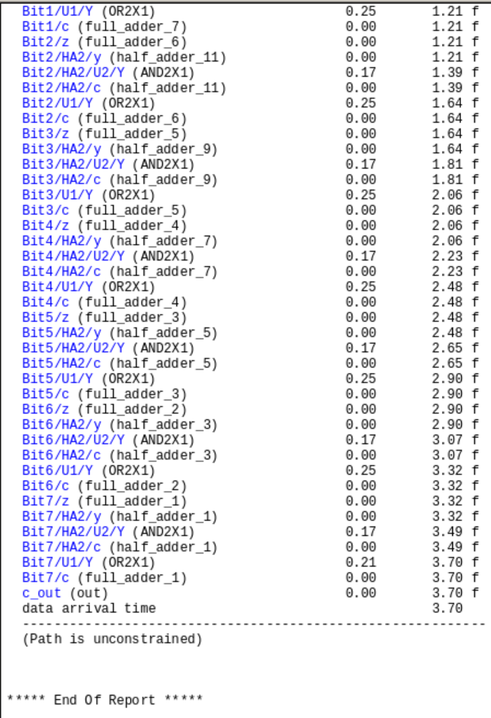

For combinational circuit, there is only data arrival time information result from gate delays.

1. **Critical Path Highlight**

One of the methods is: Select->Paths From/Through/to

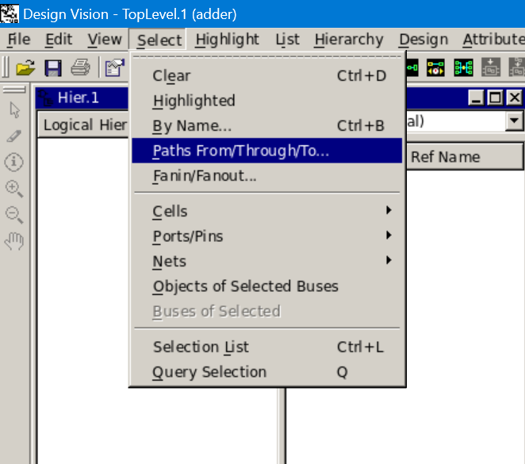

Then set the delay type to max.

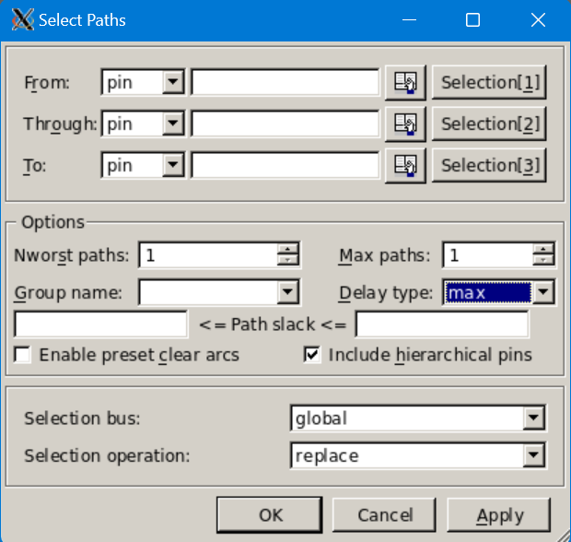

The critical path will be highlighted on the schematic window using a white line.

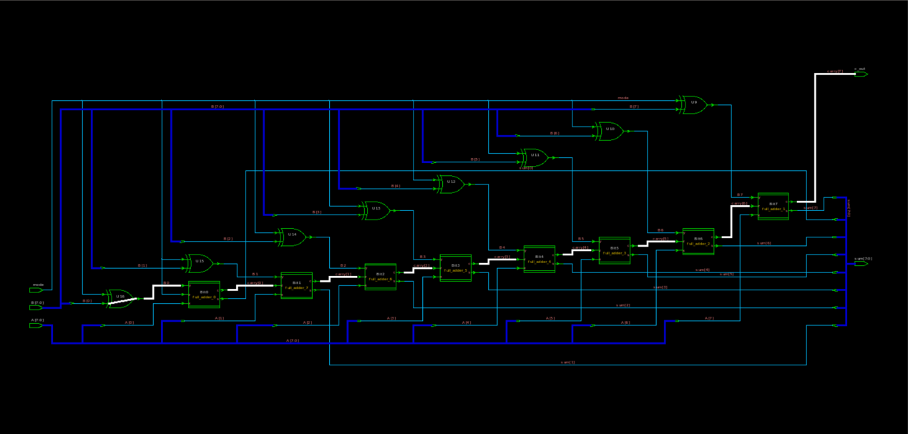

The other method is: Schematic->Paths From/Through/to

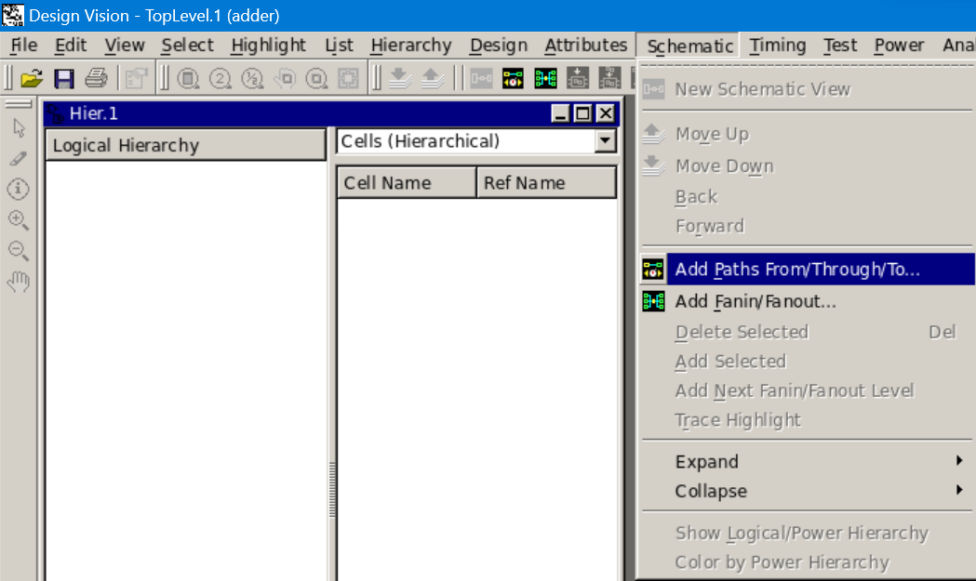

Then set the delay type to max.

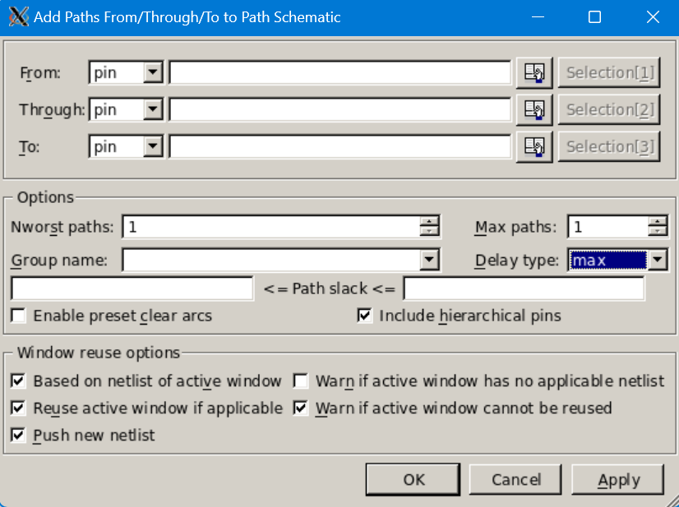A new window will open up showing the entire critical path, gate by gate.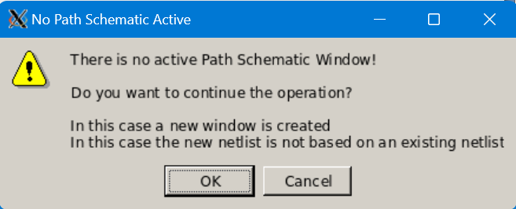

1. **Power Report**

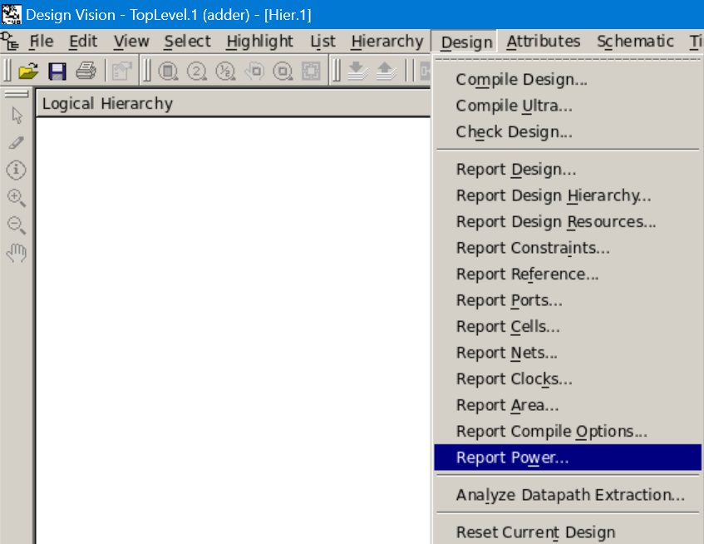

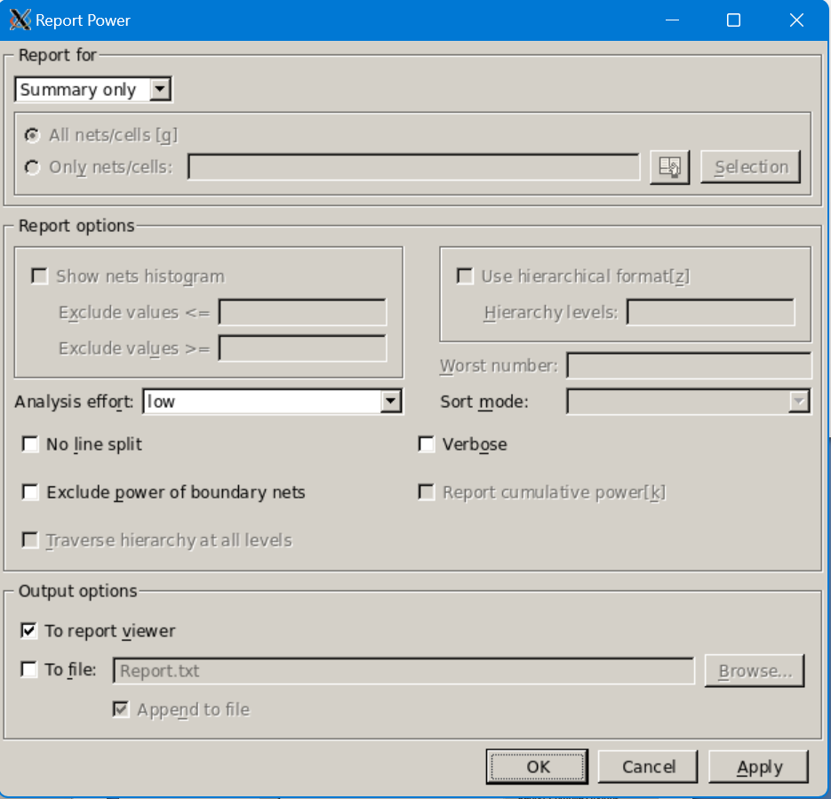

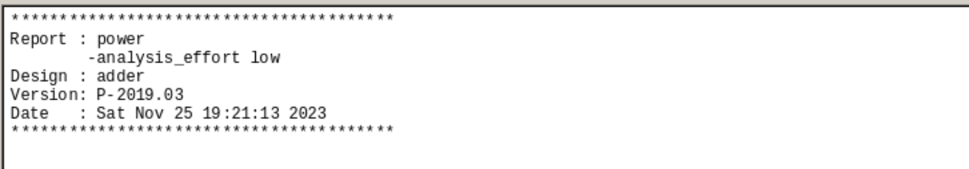

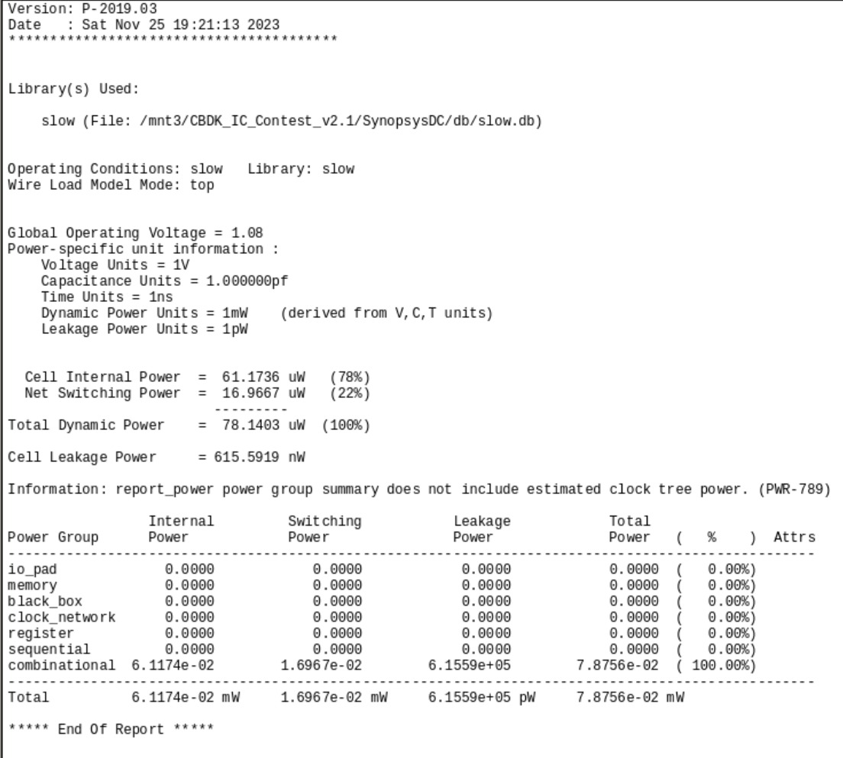

1. **Save Design Circuit and Timing Files**

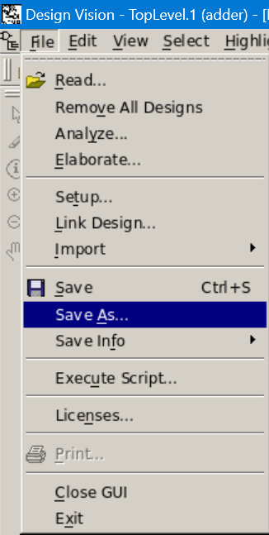

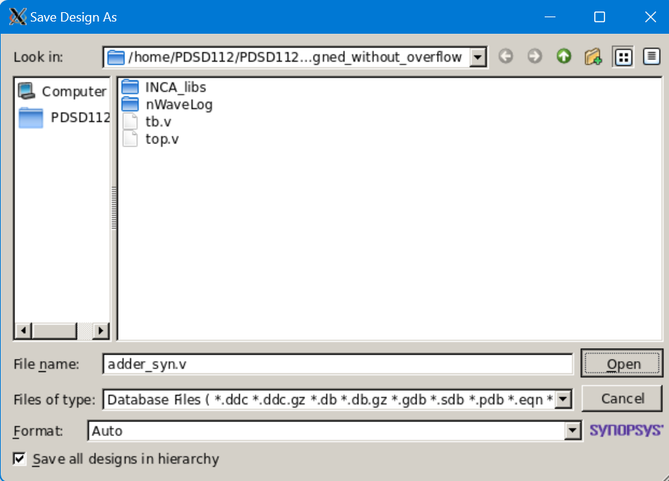

Type ‘write_sdf –version 1.0 –context verilog counter.sdf’.



1. **Rerun Verilog Simulation**

Modify the testbench:

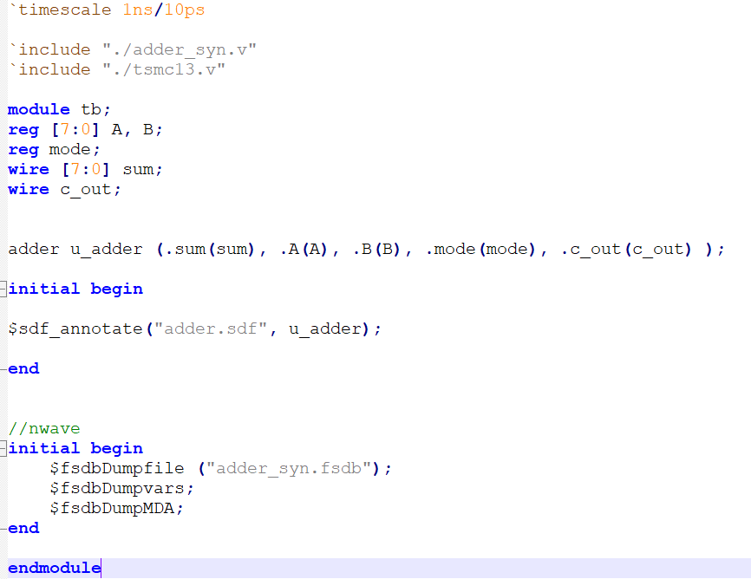

Enter ‘ncverilog tb.v +access+r’ in the workstation command line to initiate the simulation.

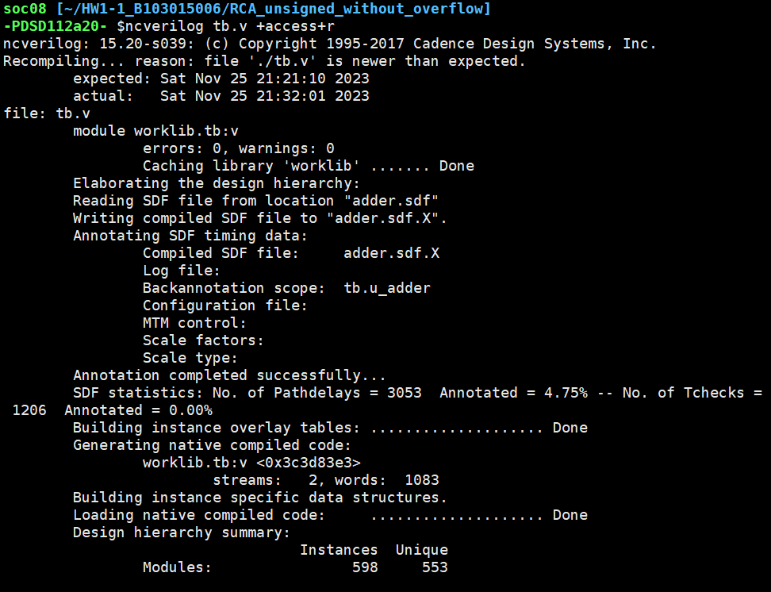

Make sure ‘Annotation completed successfully’ is in terminal.

Open nWave and find testbench module name.

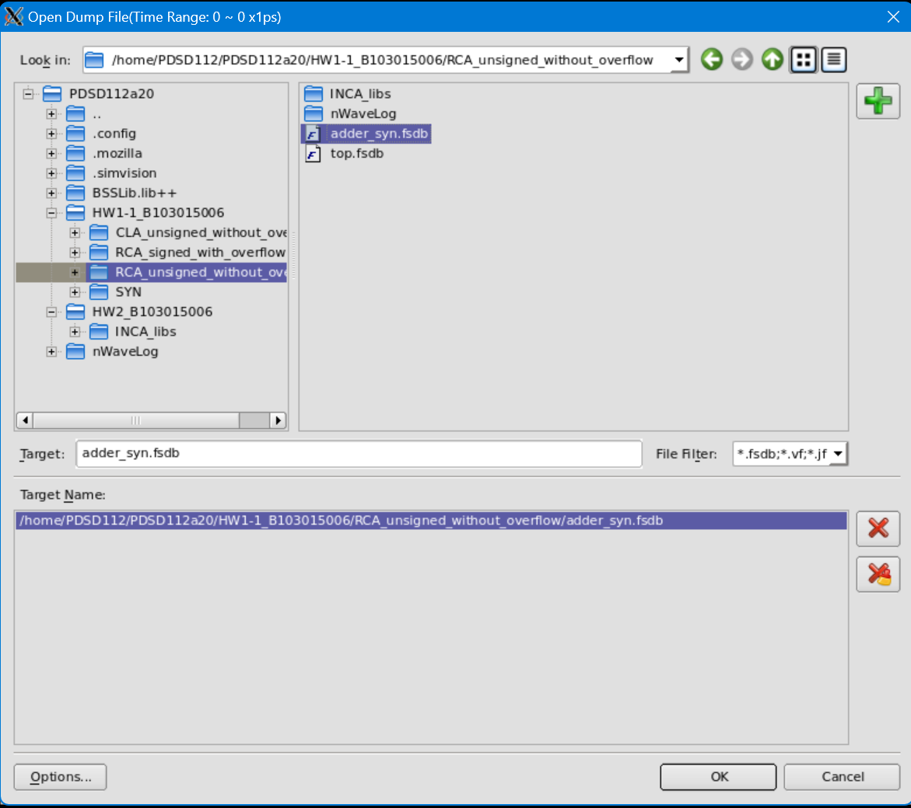

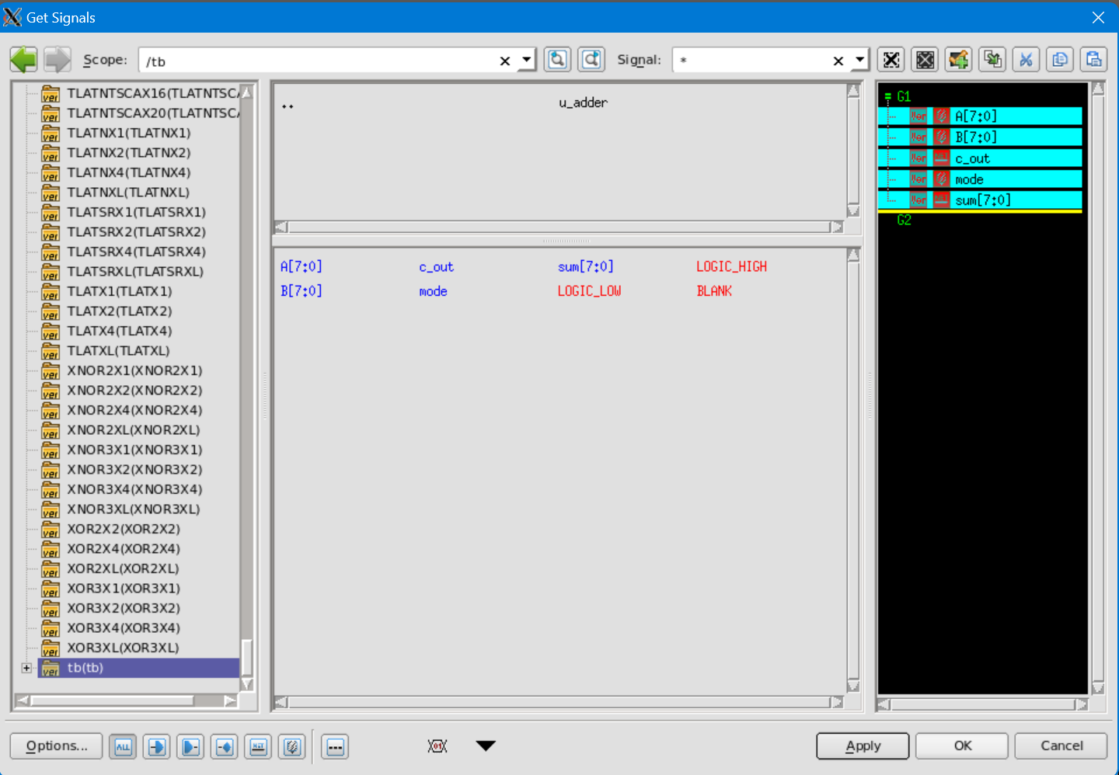

Select signals to be observed.

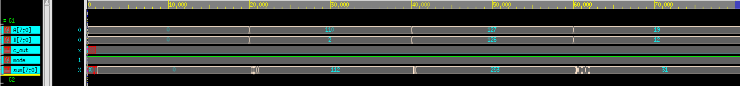

Delay effect can be observed.

1. **Circuit Analysis**
2. **RCA**

Pre-synthesizes:

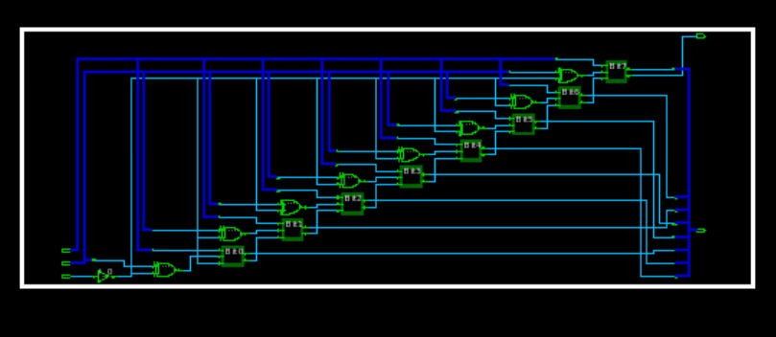

Post-synthesizes:

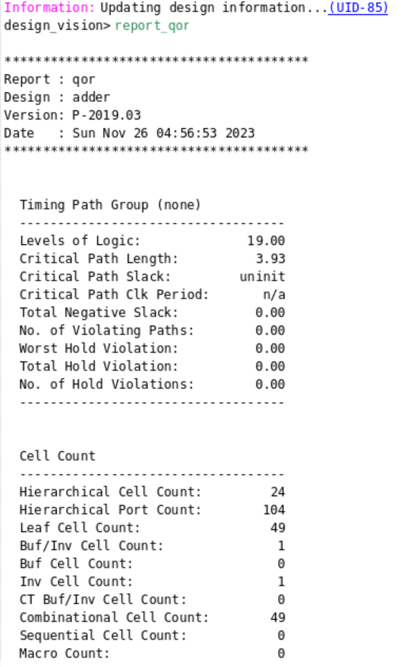

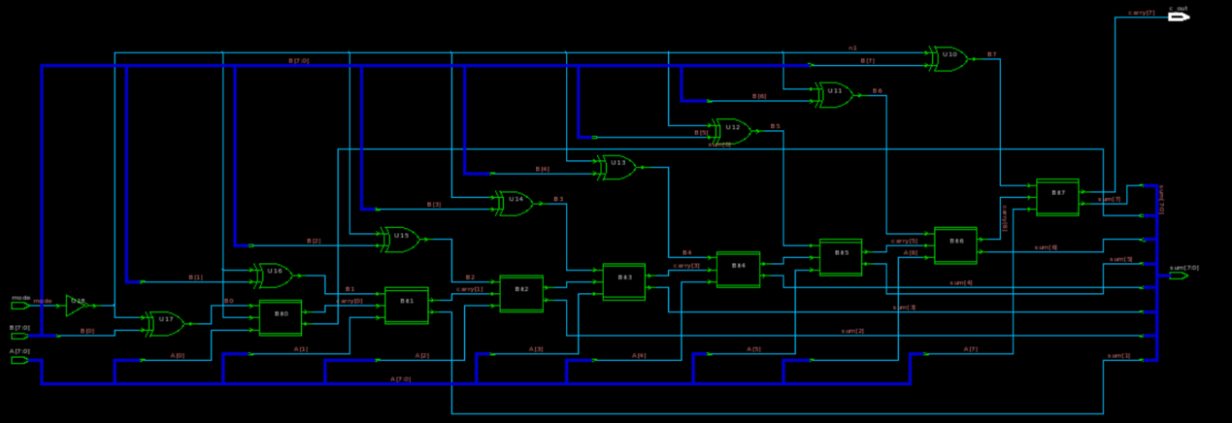

Comparison:

Post-synthesis:

Level of Logic: 19

Combinational Cell Count: 49

The structure of pre-synthesis and post-synthesis circuit is approximately equivalent, they are both consisted of 8 FAs and XOR gates.

1. **Critical Path**

The critical path passes 1 NOT gate, 2 XOR gates, 8 AND gates and 8 OR gates.



1. **Area**

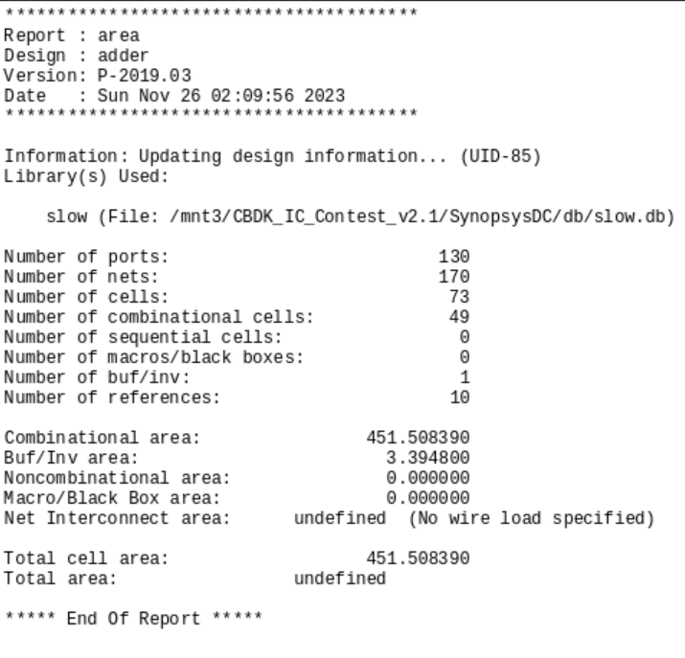

Total cell area: 451.508390 um $×$ um

Area of a NAND2 gate is approximately:

1. 5 um $×$ um for a 0.13um technology
2. 10 um $×$ um for a 0.18um technology

Gate count = reported area/ area of a NAND2 gate

1. 451.508390/5 = 90.3678 in 0.13um technology

451.508390/10 = 45.1508390 in 0.18um technology

1. **Power**

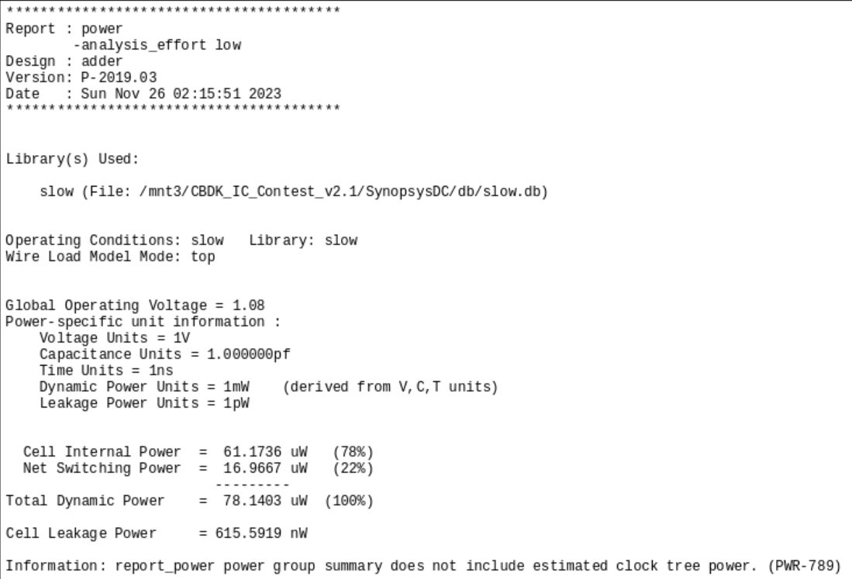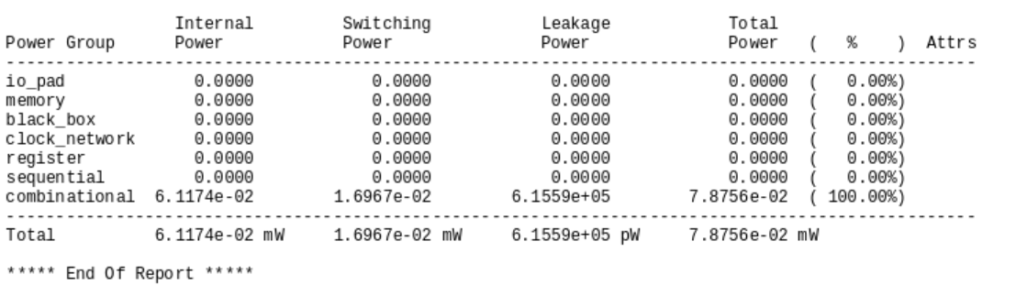

Total Dynamic Power: 78.1403 uW

1. **Delay**

Result from gate delays: 3.93 ns

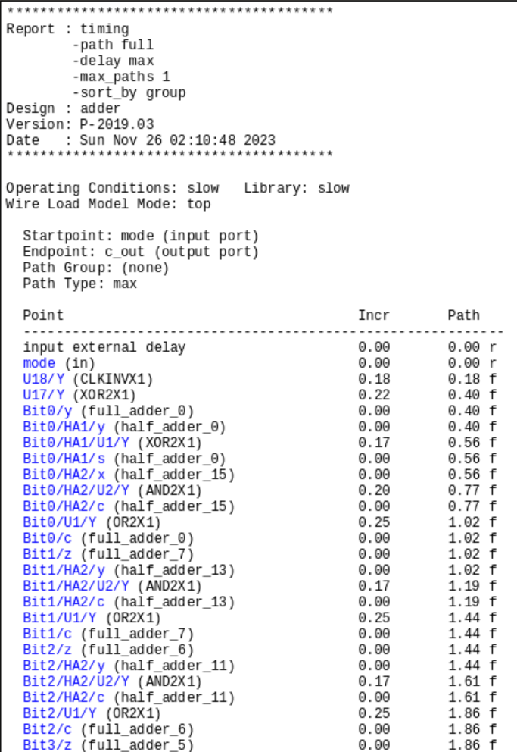 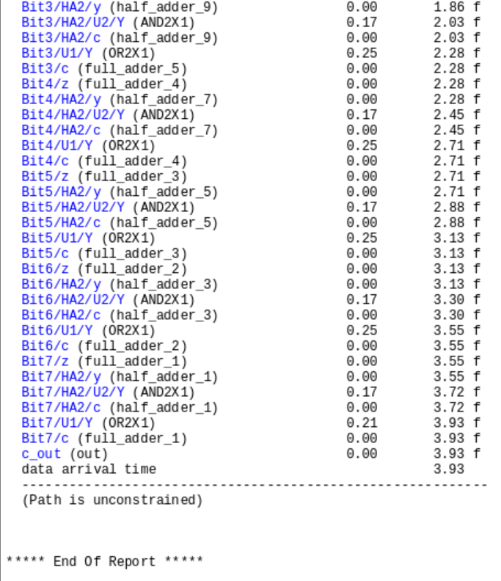

1. **CLA**

Pre-synthesizes:

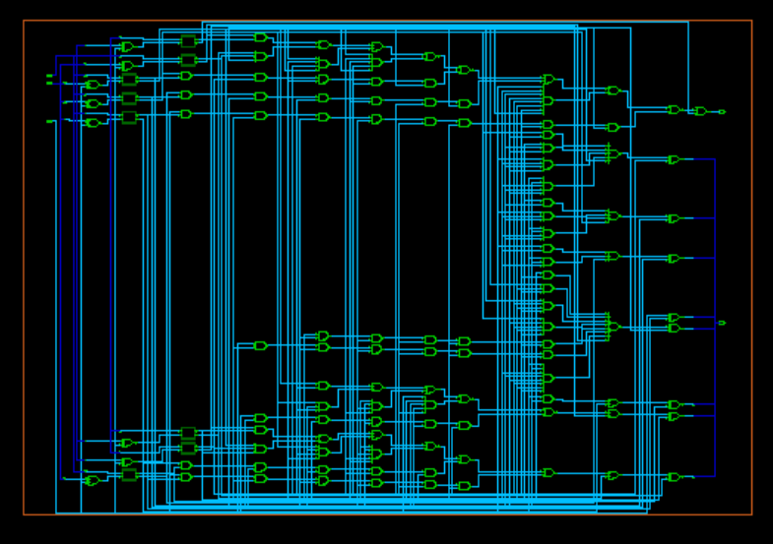

Post-synthesizes:

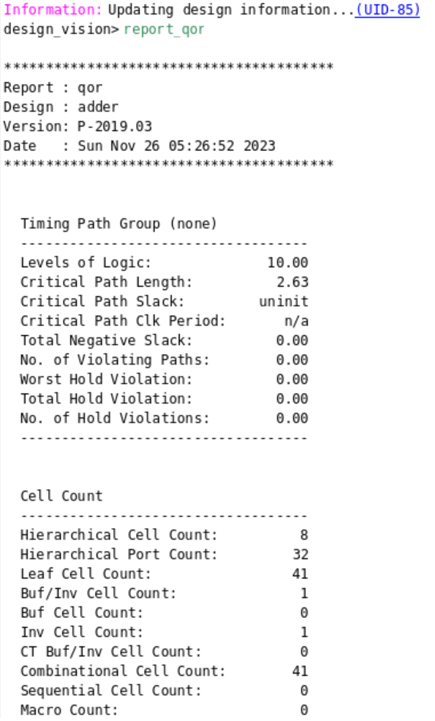

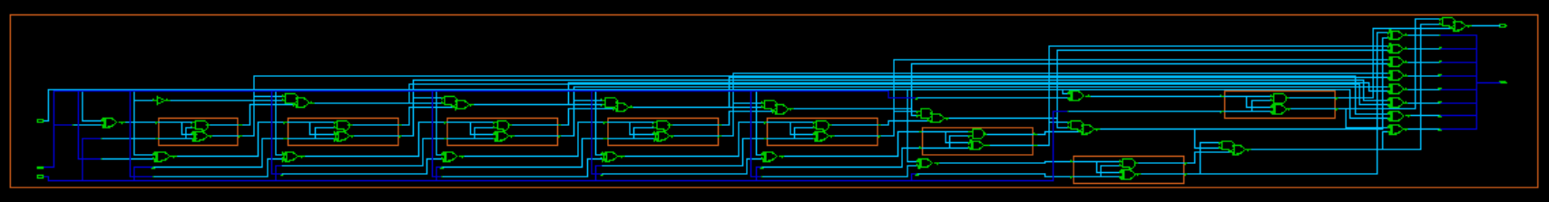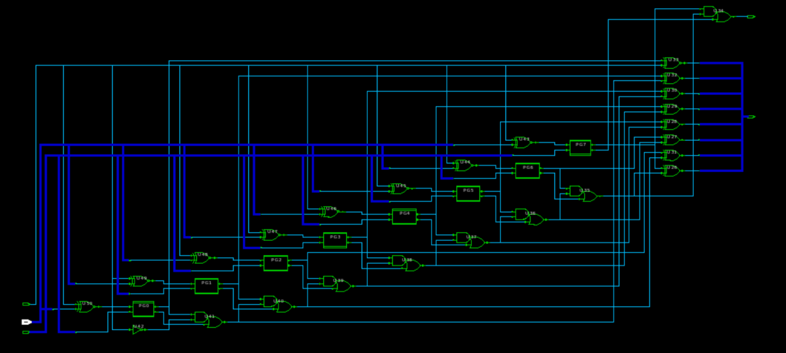

Comparison:

Post-synthesizes:

Level of Logic: 10

Combinational Cell Count: 41

The pre-synthesizes circuit has more logic gates but with less layers, while the post-synthesizes circuit has less logic gates but with more layers.

1. **Critical Path**

The critical path passes 1 NOT gate, 2 XOR gates, 8 AND gates and 8 OR gates.

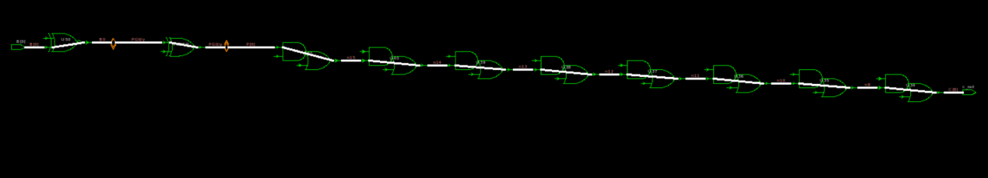

1. **Area**

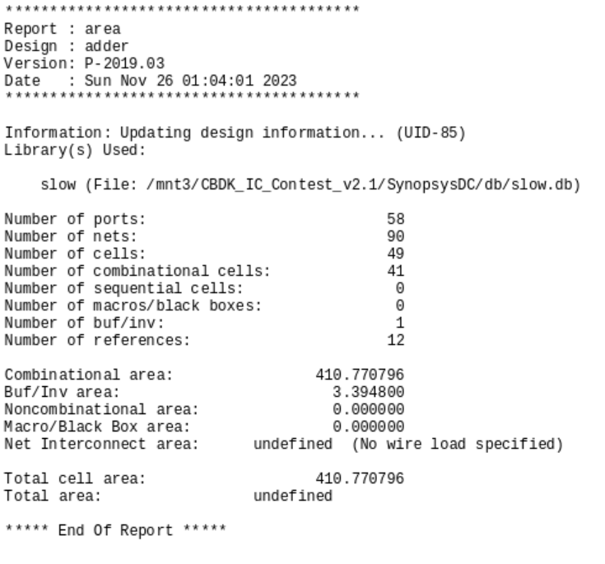

Total cell area: 410.770796 um $×$ um

Area of a NAND2 gate is approximately:

1. 5 um $×$ um for a 0.13um technology
2. 10 um $×$ um for a 0.18um technology

Gate count = reported area/ area of a NAND2 gate

1. 410.770796/5 = 82.1541592 in 0.13um technology
2. 410.770796/10 = 41.0770796 in 0.18um technology
3. **Power**

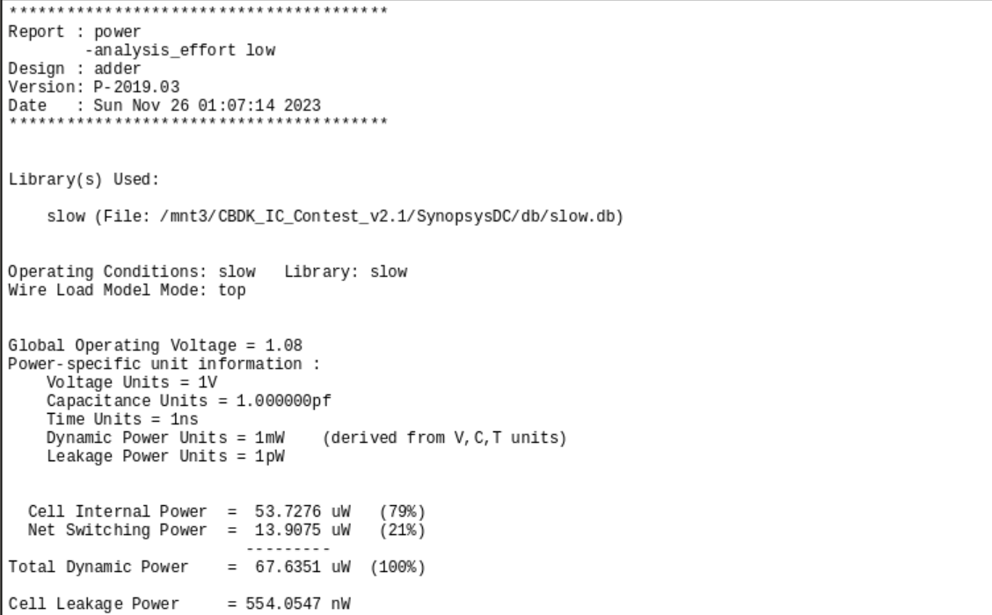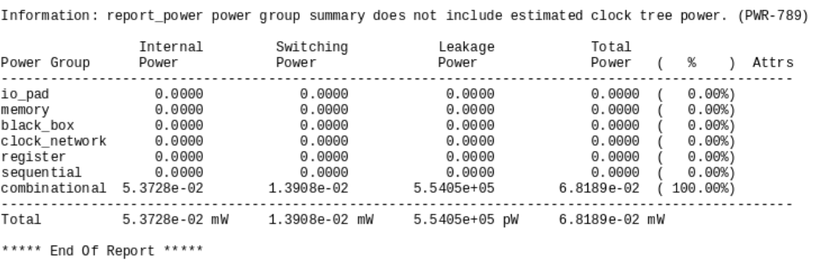

Total Dynamic Power: 67.6351 uW

1. **Delay**

Result from gate delays: 2.63 ns

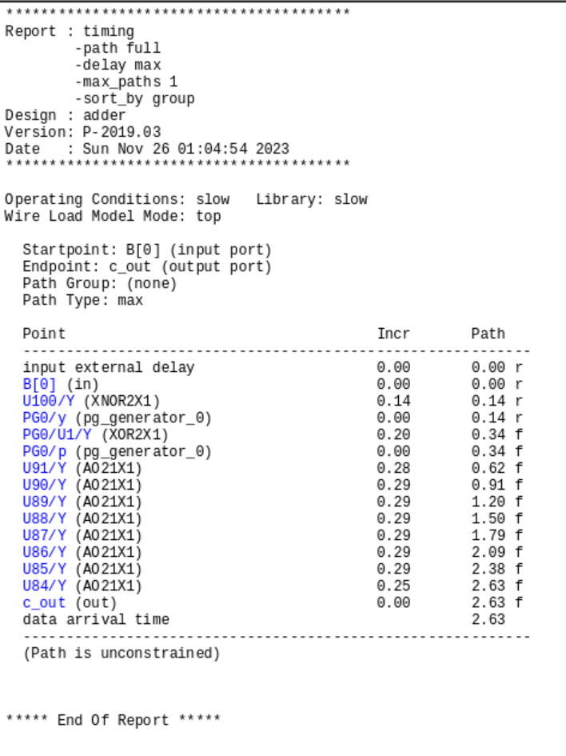

1. **Voter**

Pre-synthesizes:

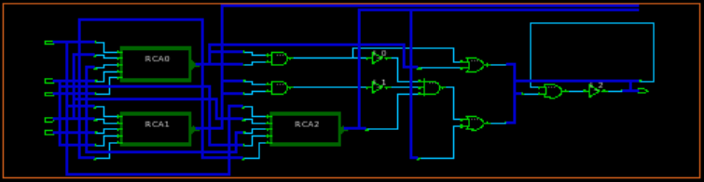

Post-synthesizes:

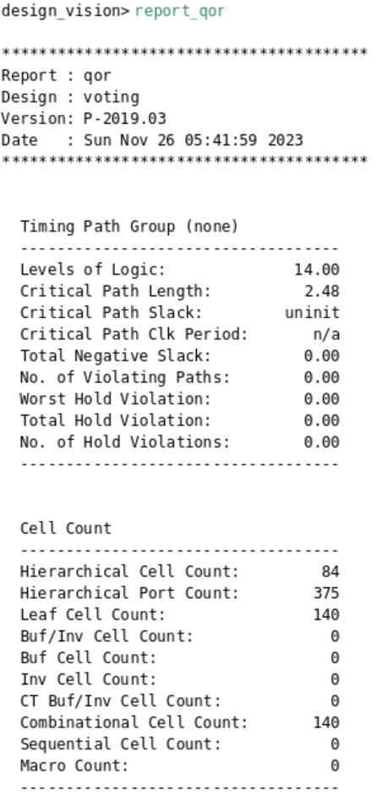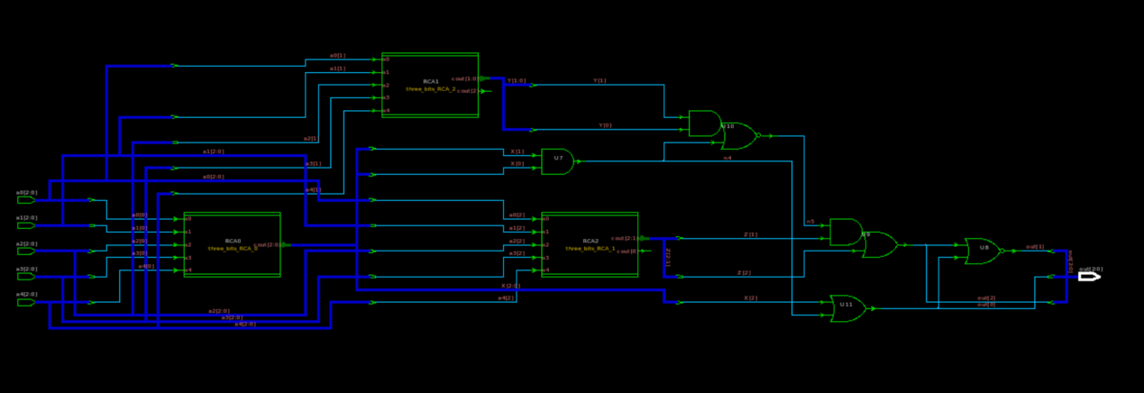

Comparison:

Post-synthesizes:

Level of Logic: 14

Combinational Cell Count: 140

The structure of the pre-synthesizes circuit and the post-synthesizes circuit are approximately equivalent, they are all consist of three 3-bit-to-5-bit adder; however, the post-synthesizes circuit has less logic gates but with more layers.

1. **Critical Path**

The critical path passes 0 NOT gate, 5 XOR gates, 3 AND gates and 6 OR gates.

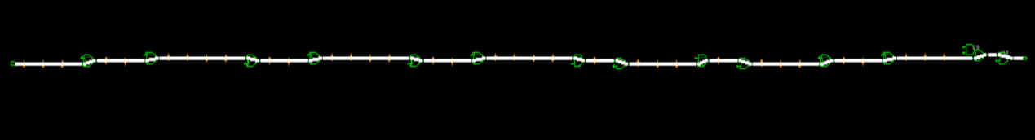

1. **Area**

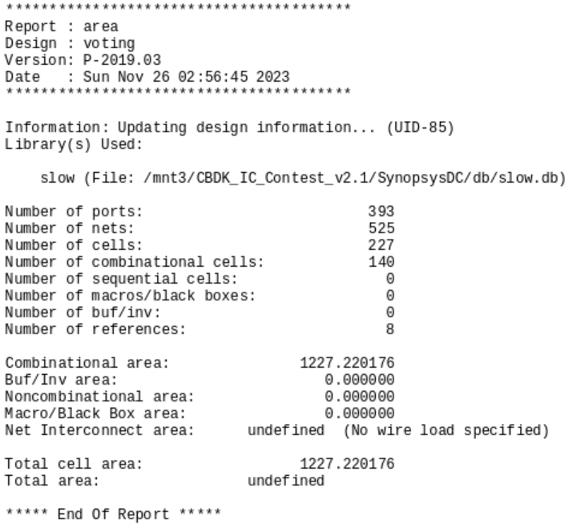

Total cell area: 1227.220176 um $×$ um

Area of a NAND2 gate is approximately:

1. 5 um $×$ um for a 0.13um technology
2. 10 um $×$ um for a 0.18um technology

Gate count = reported area/ area of a NAND2 gate

1. 1227.220176/5 = 245.4440352 in 0.13um technology
2. 1227.220176/10 = 122.7220176 in 0.18um technology
3. **Power**

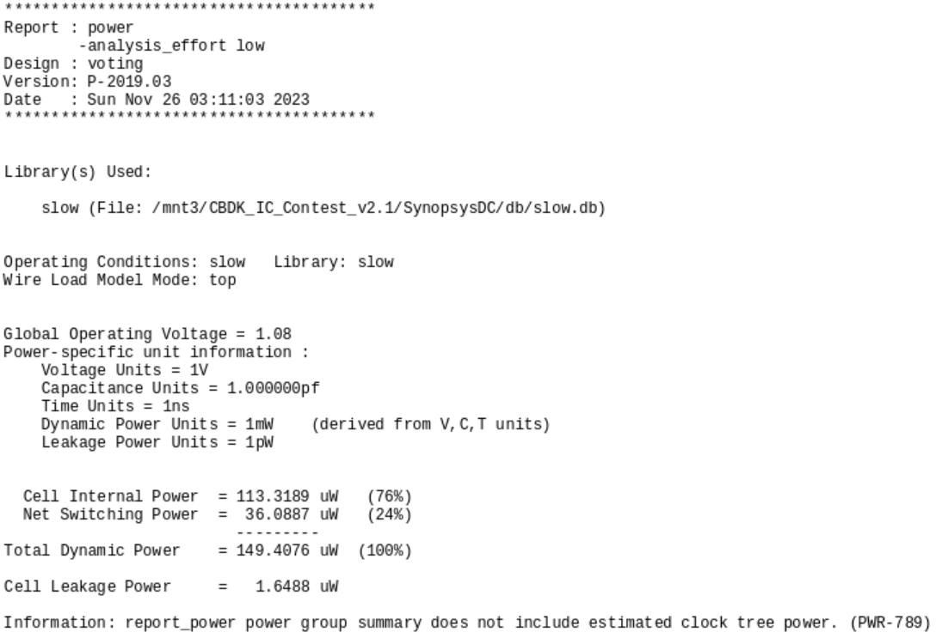

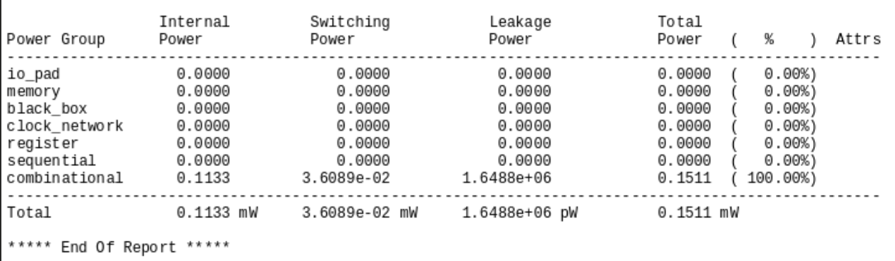

Total Dynamic Power: 149.4976 uW

1. **Delay**

Result from gate delays: 2.48 ns

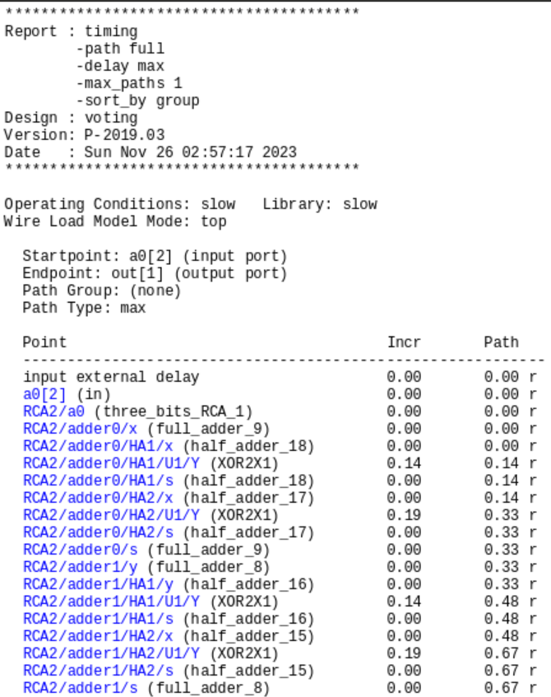

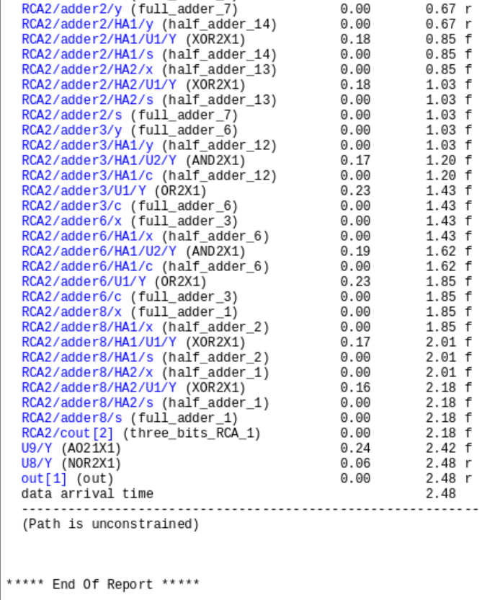

1. **Median**

Pre-synthesizes:

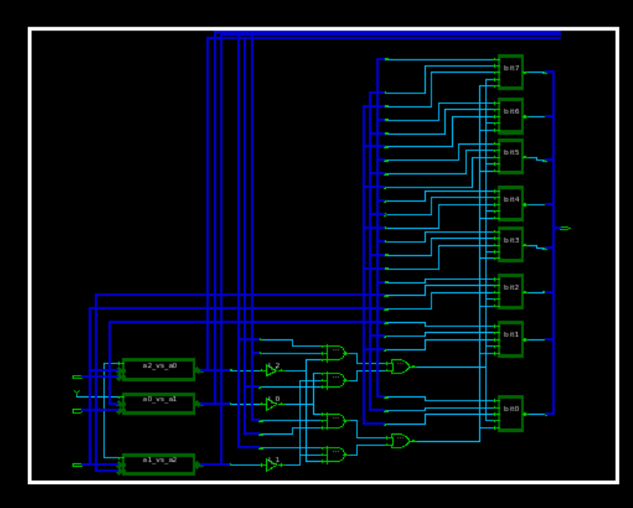

Post-synthesizes:

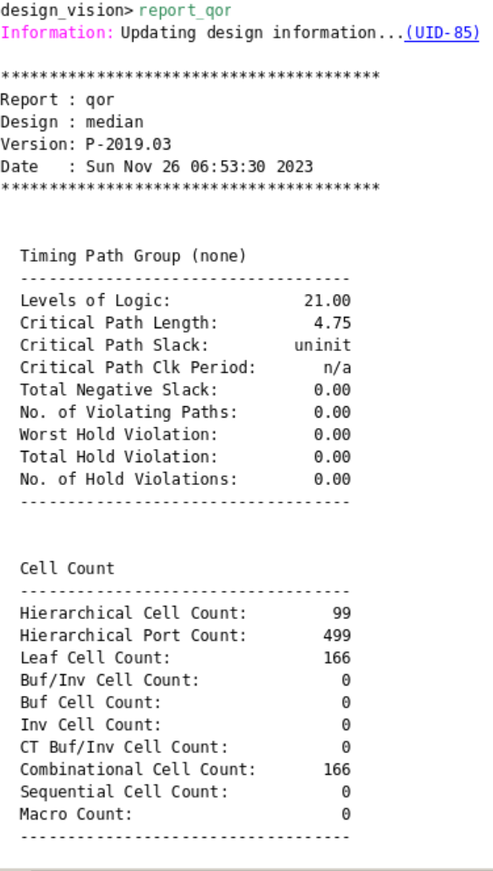

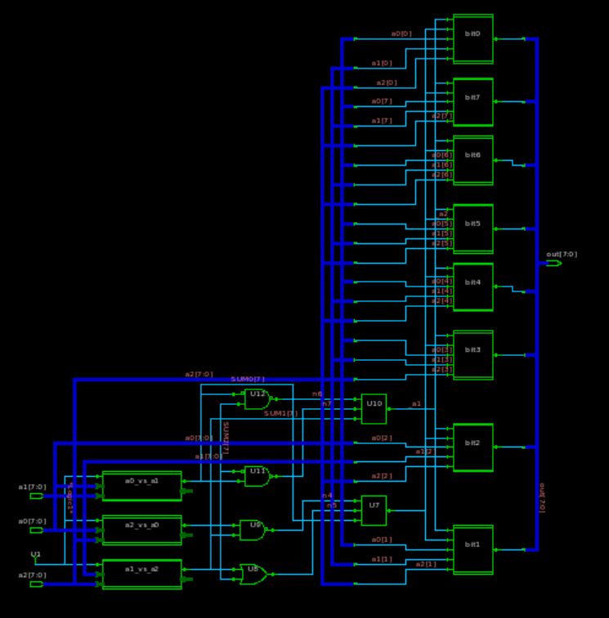

Comparison:

Post-synthesizes:

Level of Logic: 21

Combinational Cell Count: 166

The structure of the pre-synthesizes circuit and the post-synthesizes circuit are approximately equivalent, they are all consist of eight 8-bit adder, three select bit, and 2-to-1 MUX; however, the post-synthesizes circuit has less logic gates but with more layers.

1. **Critical Path**

The critical path passes 0 NOT gate, 3 XOR gates, 7 AND gates, 7 OR gates, 1 NAND gate and 2 2-to-1 MUX.



1. **Area**

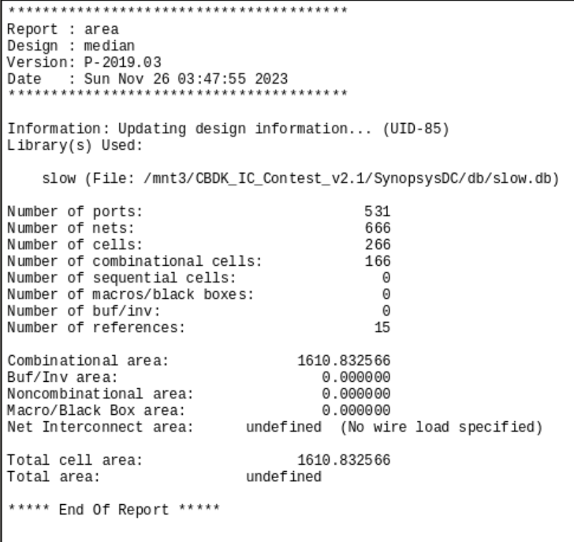

Total cell area: 1610.832566 um $×$ um

Area of a NAND2 gate is approximately:

1. 5 um $×$ um for a 0.13um technology
2. 10 um $×$ um for a 0.18um technology

Gate count = reported area/ area of a NAND2 gate

1. 1610.832566/5 = 322.1665132 in 0.13um technology
2. 1610.832566/10 = 161.0832566 in 0.18um technology
3. **Power**

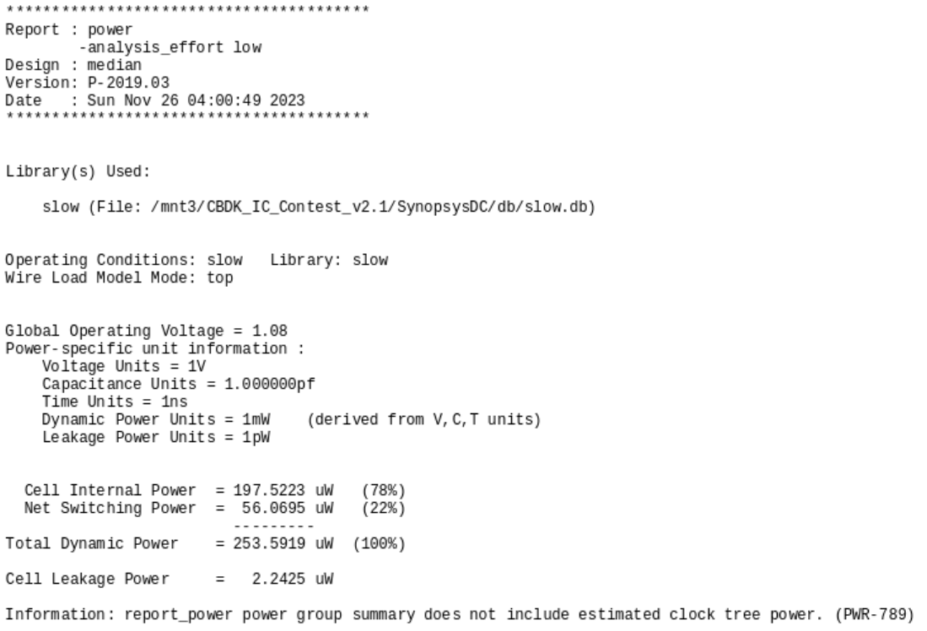

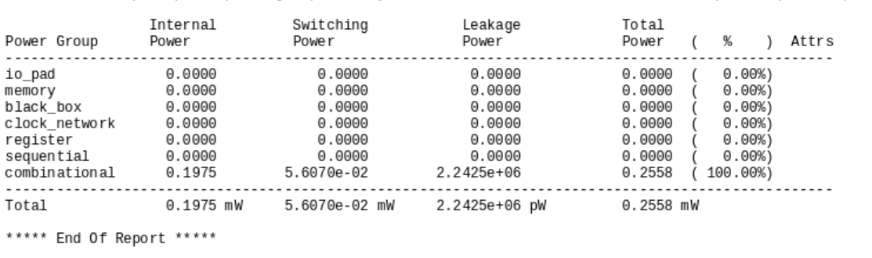

Total Dynamic Power: 197.5223 uW

1. **Delay**

Result from gate delays: 4.75 ns

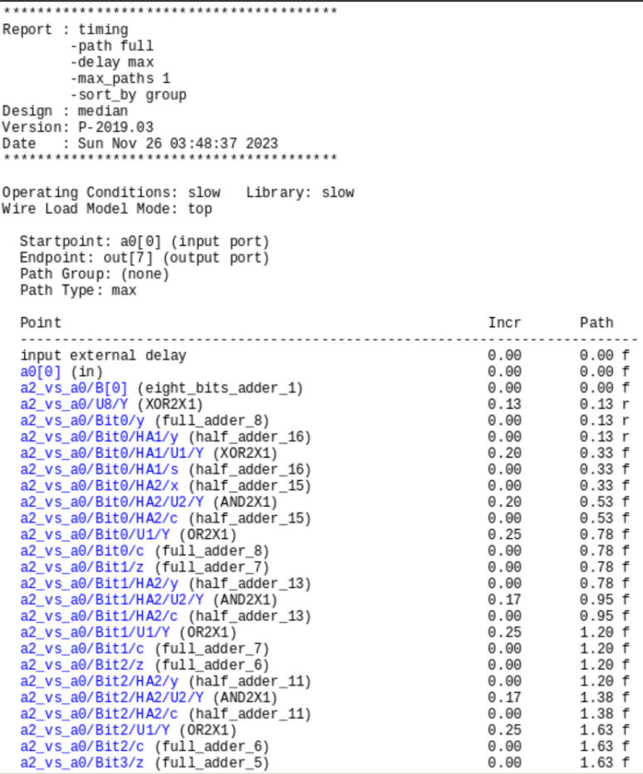 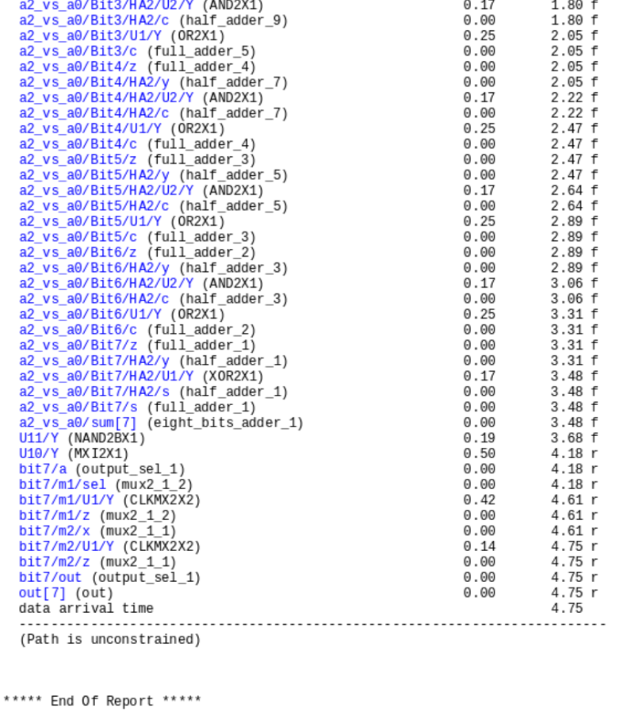

1. **Testbench**
2. **Ripple Carry Adder and Carry Look Ahead Adder**
   * + 1. **Addition of Positive Number**

RCA:

CLA:

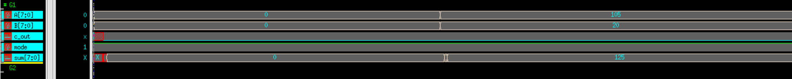

Condition 1:

A=0, B=0, mode=1, c_out=0, sum=0

Analysis 1:

0+0=0, and the value is in the range of [-127,127], without overflow and carry out, hence the result is correct.

Condition 2:

A=105, B=20, mode=1, c_out=0, sum=0

Analysis 1:

105+20=125, and the value is in the range of [-127,127], without overflow and carry out, hence the result is correct.

* + - 1. **Subtraction of Positive Number**

RCA:

CLA:

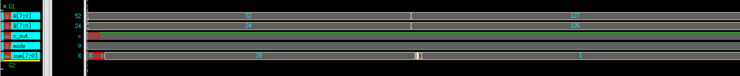

Condition 1:

A=52, B=24, mode=0, c_out=1, sum=28

Analysis 1:

52-24=28, and the value is in the range of [-127,127], without overflow but has a carry out, hence the result is correct.

Condition 2:

A=127, B=126, mode=0, c_out=1, sum=1

Analysis 1:

127-126=1, and the value is in the range of [-127,127], without overflow and carry out, hence the result is correct.

* + - 1. **Addition of Negative Number**

RCA: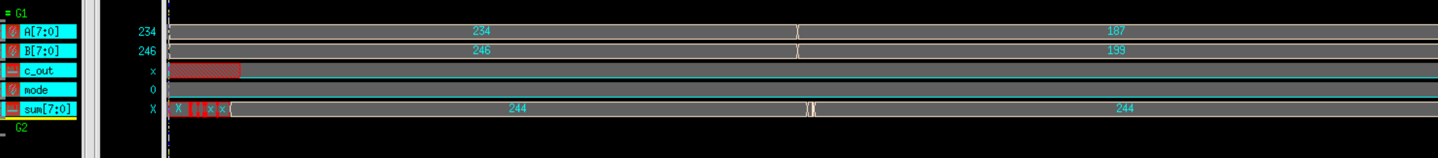

CLA:

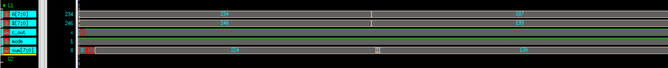

Condition 1:

A=234, B=246, mode=1, c_out=1, sum=224

234 is not in the range of [-127,127], so it will be shown as its compliment: -22.

246 is not in the range of [-127,127], so it will be shown as its compliment: -10.

Sum=224, which is not in the range of [-127,127], so it will be shown as its compliment: -32.

Analysis 1:

(-22)+(-10)=-32, and the compliment of -32 is 224, hence the result is correct.

Condition 2:

A=187, B=199, mode=1, c_out=1, sum=130

187 is not in the range of [-127,127], so it will be shown as its compliment: -69;.

199 is not in the range of [-127,127], so it will be shown as its compliment: -57.

Sum=130, which is not in the range of [-127,127], so it will be shown as its compliment: -126;

Analysis 1:

(-69)+(-57)=-126, and the compliment of -126 is 130, hence the result is correct.

* + - 1. **Subtraction of Negative Number**

RCA:

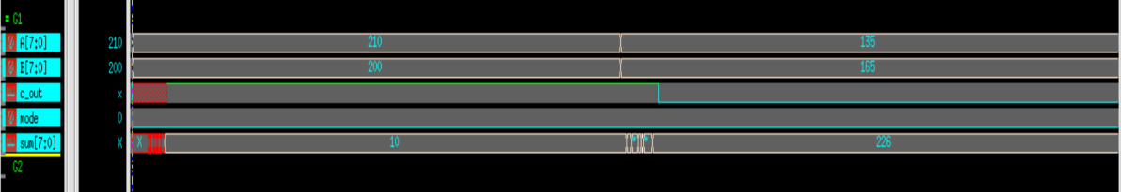

CLA:

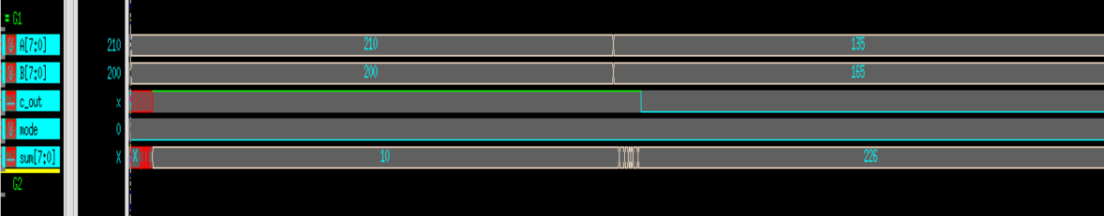

Condition 1:

A=210, B=200, mode=0, c_out=1, sum=10

210 is not in the range of [-127,127], so it will be shown as its compliment: -46.

200 is not in the range of [-127,127], so it will be shown as its compliment: -56.

Sum=10, which is in the range of [-127,127].

Analysis 1:

(-46)-(-56)=10, without overflow but has a carry out, hence the result is correct

Condition 2:

A=135, B=165, mode=0, c_out=1, sum=226

135 is not in the range of [-127,127], so it will be shown as its compliment: -121.

165 is not in the range of [-127,127], so it will be shown as its compliment: -9.

Sum=226, is not in the range of [-127,127], so it will be shown as its compliment: -30.

Analysis 2:

(-121)-(-91)=-30, and the compliment of -30 is 226, hence the result is correct.

* + - 1. **Overflow**

RCA:

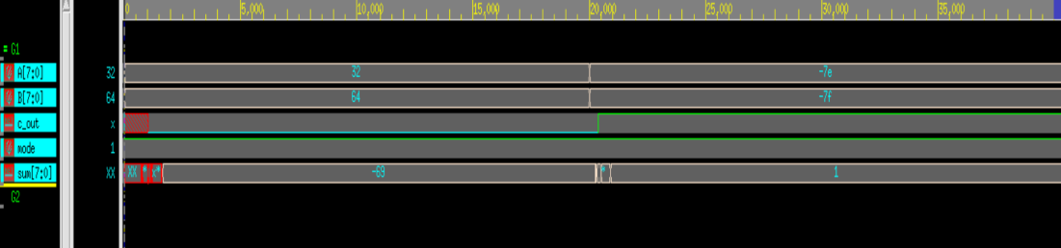

CLA:

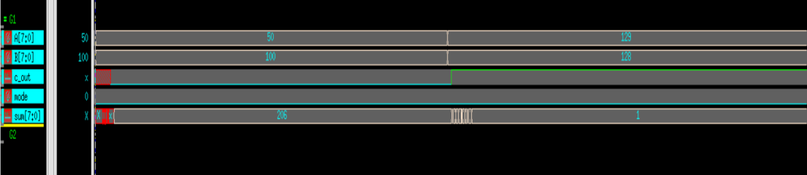

Condition 1: 2 positive number addition, result exceed 127 and causes overflow.

A=50, B=100, mode=0, c_out=0, sum=150

50 and 100 are in the range of [-127,127].

Sum=50, is not in the range of [-127,127].

Analysis 1:

50+100=150, which is not in the range of [-127,127], so it will be seen as overflow without carry out

Condition 2: 2 negative number addition, result smaller than -127 and causes overflow.

A=129, B=128, mode=0, c_out=1, sum=1

129 is not in the range of [-127,127], so it will be shown as its compliment: -127.

128 is not in the range of [-127,127], so it will be shown as its compliment: -128.

Sum=1, is in the range of [-127,127].

Analysis 2:

(-127)+(-128)=-255, overflowed, and the compliment of -255 is 1, hence the result is correct.

